Weekly Report
Feb 23th
Yamei Xiao
Comparing path with paper Ant Colony System Based Mobile Robot Path Planning, by Song-Hiang Chia, Kuo-Lan Su, Jr-Hung Guo, Cheng-Yun Chung.
‘The ants search the food from the nest, and moves in the blind alley. The second experiment scenario of the ACO system set a “ㄇ” type obstacle on the grid platform. The ACO processing produces random results. The ant may
moves to the blind alley to delete the position of the path in the memo. The next ant can’t select the path in the blind alley. Finally, the ACO program was executed many times to determine the minimum possible distance obtained.’
Figure 1. “ㄇ” type map in paper
Consider distance and angle in each step, our simulation result is shown in figure 2.
Figure 2. “ㄇ” type map simulation result
Simulate a few times to get more results, among them, the length is almost the same, I capture the most smooth one.
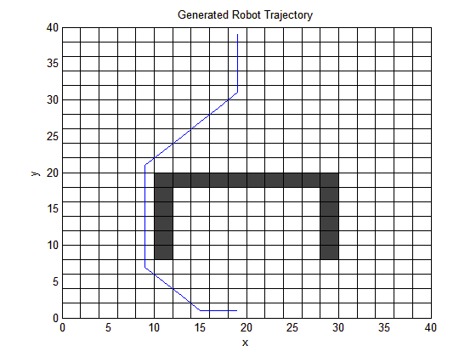
Figure 3. The most smooth “ㄇ” type map simulation result
α =1, β = 5, ρ = 0.2
Iterations=200
The minimum path length is 48.6274. The path length in the paper is not given, we can calculate it, it is also 48.6274.

The position of the ant nest is (19,11), and the position of the food is (19,39). The third experiment scenario of the ACO system set a “ㄇ” type and an “U” type obstacles on the grid platform. The big “ㄇ” type obstacle contains the small “U” type obstacle to be shown in Fig. 8. The start position of the ant system is in the blind alley.
Figure 1. double U type map in paper

Figure 2. double U type map simulation

This case is a little complicated, ant choose path randomly. The simulation result is not good enough.

